**In-Class Task 2 Instructions: Enhance the Future Value application**

In this In-Class Task, you’ll make a quick enhancement that shows not only the future value when interest is compounded yearly, but also when it’s compounded monthly. As a result, the display in the browser should look like this:

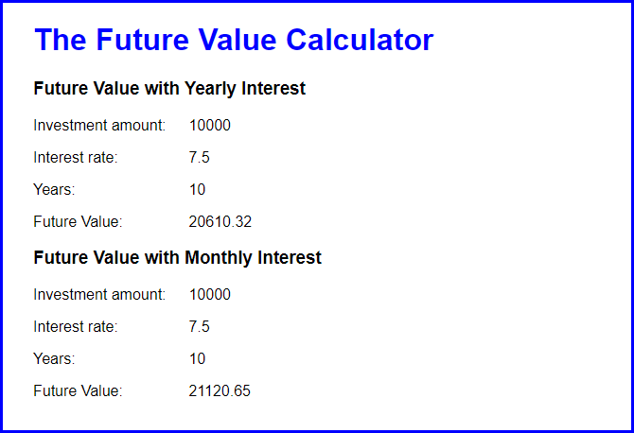

1. Open application in this folder:

Evaluations\In-Class Tasks\In-Class Task 2\future_value.zip

1. Run the application to make sure it works correctly.
2. Review its code. Note that it is just like the code in the book and that the interest is calculated each year.
3. Add the code for calculating the future value when interest is calculated each month. Then, add the code for displaying the results, as shown above. Be sure to add the heading that identifies each result.